Techlynx - Case study
Problem statement:
Assumptions:
Persona:
MVP vision:
How to measure the MVP (AARRR): user story:
Wire framing:
Bonus: Risk Analysis Approach:
Answer to Question 1:
Answer to Question 2: Data summary:
Pattern & theory:
Recommendation:

Document type | Case study
Document owner | Maram Essam (product manager)
Deliver to | X - Comapny
Date | 25/8/2024

Problem statement:
(SOHO) sellers are struggling to efficiently manage their deliveries due to a lack of accessible, mobile-friendly tools. They need a simple, seamless way to sign up, create shipping orders, and schedule pickups without technical barriers. Techlynx aims to solve this by providing a user-friendly mobile platform tailored to their needs.

Assumptions:

- Integrated Payment with Techlynx, so the merchant can pay his registrations.
- We’ve our own Development team, design team and customer service team.
- We’ve a product analyst, so we can analyze our customer behavior using Mixpanel or any analytical tool.

Persona:

Name | Description | Challenges
SOHO | (Small Office Home Office) | Non-tech savvy, using mobile app only

User Story | Metrics for Success | Acceptance Criteria | Include in MVP?

As a SOHO seller, I want to easily sign up on Techlynx using my mobile device so that I can start using the delivery services. | Number of successful sign-ups per day  Time taken to complete sign-up process  User satisfaction rating during onboarding | User can sign up within 2 minutes  user should enter user name, email, password, number of monthly orders, type of products and government.  Mobile sign-up process is error-free Select the package  and pay it.  Confirmation email/SMS sent upon successful registration | Yes
As a SOHO seller, I want to be able to create and manage shipping orders from my mobile device so that I can ship my products efficiently. | Number of shipping orders created  Order completion rate  User feedback on order creation experience | User can add the shipping weight, shipping address and pickup.  Shipment details. Consignees details (name, email,  address, mobile).  AWB should be created with ability to be downloaded as PDF.  Order management page loads within 2 seconds  Orders can be edited before pickup | Yes
As a SOHO seller, I want to be able to schedule pickups for my products from my mobile device so that they can be delivered to customers without hassle. | Number of pickups scheduled  Pickup success rate Reduction in missed pickups | User can schedule a pickup with preferred time slot and location.  Confirmation is sent after scheduling  Pickup can be rescheduled if needed within 1 day | Yes
As a SOHO seller, I want to receive a tracking number for each order so that my customers can monitor the delivery status. | Percentage of orders with tracking numbers generated  Accuracy of tracking information  Customer feedback on tracking updates | Tracking number is automatically generated upon order creation  Tracking number is sent via SMS/Email | Yes

 |  | Tracking status updates are accurate and timely
As a SOHO seller, I want to track my shipments in real-time from my mobile device so that I can ensure timely delivery to my customers. | Number of tracking updates viewed  Time spent tracking shipments  User feedback on tracking accuracy | Real-time tracking updates are accurate.  Users receive notifications for delivery milestones | No
As a SOHO seller, I want to be notified of any delivery issues or delays so that I can communicate them to my customers promptly. | Number of notifications sent for issues  Customer feedback on communication  Delivery issue resolution time | Notifications are sent within 10 minutes of issue detection  Notifications include clear instructions for next steps  Issues are resolved within 24 hours | No

MVP vision:
The vision for the MVP is to enable SOHO sellers to seamlessly sign up and sign in to Techlynx’s platform, create shipping orders, and schedule pickups through a user-friendly mobile experience. This MVP will focus on delivering core functionality that allows users to initiate and manage their delivery needs with minimal friction.

How to measure the MVP (AARRR):

Acquisition:
Metric: Number of SOHO sellers who sign up for the platform.
Goal: Achieve a significant percentage of the target market (e.g., 30% of 700K+ SOHO sellers within the first three months).

Activation:
Metric: Percentage of new users who create their first shipping order within 24 hours of signing up.
Goal: 60% of users create their first order immediately after sign-up.

Retention:
Metric: Percentage of users who return to the app to create a second order within a week of their first order.
Goal: Retain at least 50% of users through repeat orders in the first month.

Referral:
Metric: Number of users who refer other SOHO sellers to the platform.
Goal: Achieve a 10% referral rate within the first three months.

Revenue:
  - Metric: Average revenue per user (ARPU) generated from shipping orders.
  - Goal: Generate sufficient revenue from the initial user base to cover operational costs, with the potential to scale profitably

user story:
Title (sign-up)

As a SOHO seller, I want to easily sign up on Techlynx using my mobile device so that I can start using the delivery services. Acceptance criteria:
- User can sign up within 2 minutes
- user should enter user name, email, password, number of monthly orders, type of products and government.
- Mobile sign-up process is error-free
- Select the package and pay it.
- Confirmation email/SMS sent upon successful registration

Wire framing:
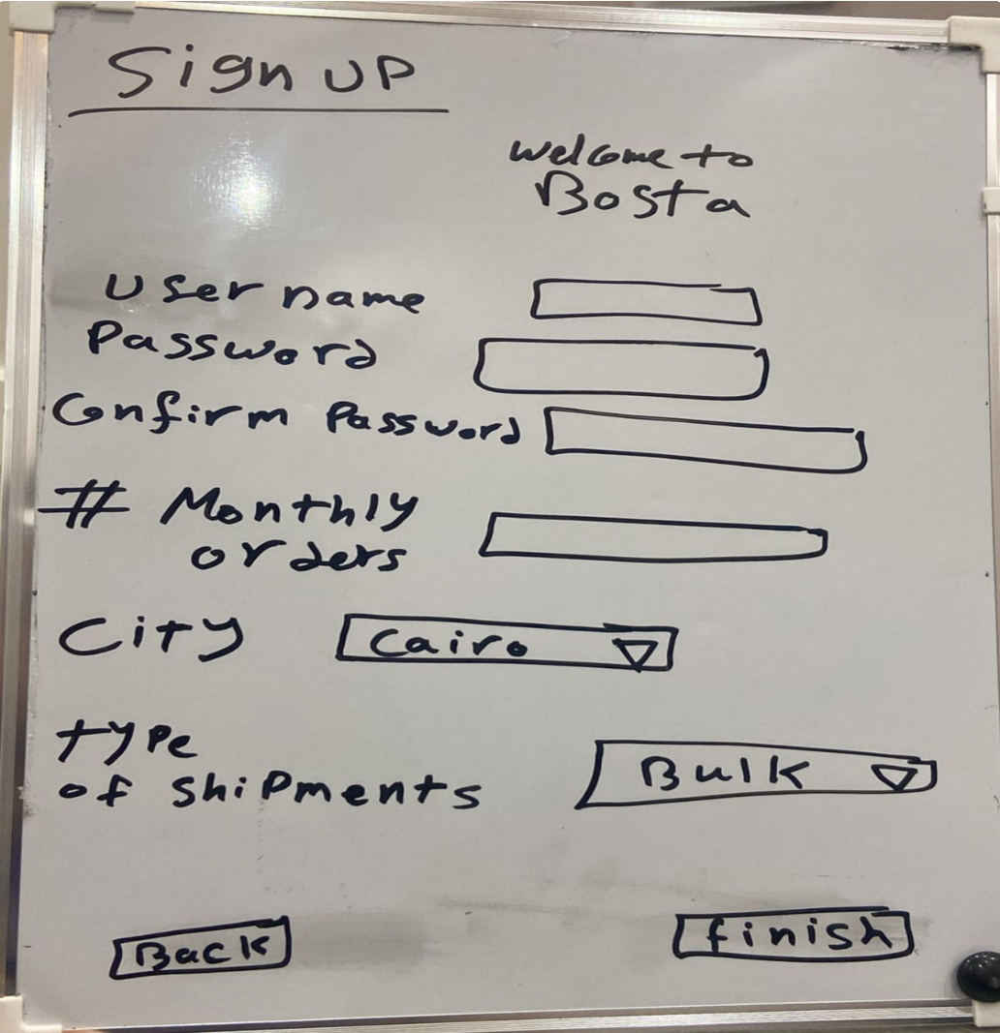

Bonus: Risk Analysis

Risk | Description | Likelihood | Impact | Mitigation  Strategy
Market | The platform may | Medium | High | Conduct thorough
Acceptance | not attract enough |  |  | market research
 | users, both buyers |  |  | before launch.
 | and sellers, leading |  |  | Implement targeted
 | to low activity and |  |  | marketing
 | revenue |  |  | campaigns. Offer
 |  |  |  | promotions and
 |  |  |  | incentives to early
 |  |  |  | adopters. Collect and act on user
 |  |  |  | feedback.
User Trust and | Users may be | High | High | Implement strict
Security | concerned about |  |  | verification
 | the authenticity of |  |  | processes for
 | antiques, payment |  |  | sellers. Use secure
 | security, and |  |  | payment gateways.
 | personal data |  |  | Ensure compliance
 | protection. |  |  | with data protection
 |  |  |  | regulations.
 |  |  |  | Provide
 |  |  |  | transparency and
 |  |  |  | detailed
 |  |  |  | descriptions for
 |  |  |  | listed items.
Technical Issues | Technical issues | Medium | High | Ensure rigorous
 | such as |  |  | testing before
 | website/app |  |  | launch. Implement
 | downtime, slow |  |  | robust monitoring
 | load times, and |  |  | and maintenance
 | bugs can lead to |  |  | systems. Have a
 | poor user |  |  | dedicated technical
 | experience. |  |  | support team to
 |  |  |  | address issues

 |  |  |  | promptly.
Competition | Strong competition | High | Medium | Differentiate the
 | from established |  |  | platform with
 | players like eBay, |  |  | unique features
 | Etsy, and 1stDibs |  |  | (e.g., expert
 | may affect market |  |  | authentication,
 | share. |  |  | high-quality
 |  |  |  | listings). Focus on
 |  |  |  | niche marketing.
 |  |  |  | Form partnerships
 |  |  |  | with antique
 |  |  |  | experts and shops.
Logistics and | Challenges in | Medium | High | Partner with
Shipping | safely and |  |  | reliable shipping
 | efficiently shipping |  |  | companies. Offer
 | valuable antiques |  |  | shipping insurance.
 | can lead to |  |  | Provide detailed
 | customer |  |  | shipping and
 | dissatisfaction. |  |  | handling guidelines
 |  |  |  | to sellers.
Feature Adoption | Users may not | Low | Medium | Conduct user
 | adopt new features |  |  | training sessions
 | or services |  |  | and provide easy
 | introduced on the |  |  | to-understand
 | platform. |  |  | tutorials. Collect user feedback to
 |  |  |  | iterate and improve
 |  |  |  | features.
 |  |  |  | Communicate the
 |  |  |  | benefits of new
 |  |  |  | features effectively.
Customer | High volume of | Low | Medium | Implement a robust
Support Load | customer support |  |  | FAQ and help
 | inquiries can |  |  | section. Use
 | overwhelm the |  |  | automated support
 | support team, |  |  | tools (chatbots).

 | leading to delayed responses and  dissatisfied users. |  |  | Scale the support team based on  demand.

Approach:
Sum Purchases by Cohort: I'll sum up the total purchases made by users in each cohort.
Compare Totals: The cohort with the highest total purchases will be considered the most successful in selling toner. Let's proceed with this analysis.

Answer to Question 1:

Cohort B had the highest total toner purchases with 7,072 units sold (38% of total purchases). Cohort A followed with 6,744 units (36% of total purchases).
Cohort C had the lowest with 4,969 units (26% of total purchases).
Final Answer: Based on the data, Cohort B is the winner as it generated the most toner sales. Therefore, I would pick variant B as the most successful in selling toner.
Whoever "A" is a big competitor to "B", we cannot ignore as a big opportunity of winning if we work on it efficiently

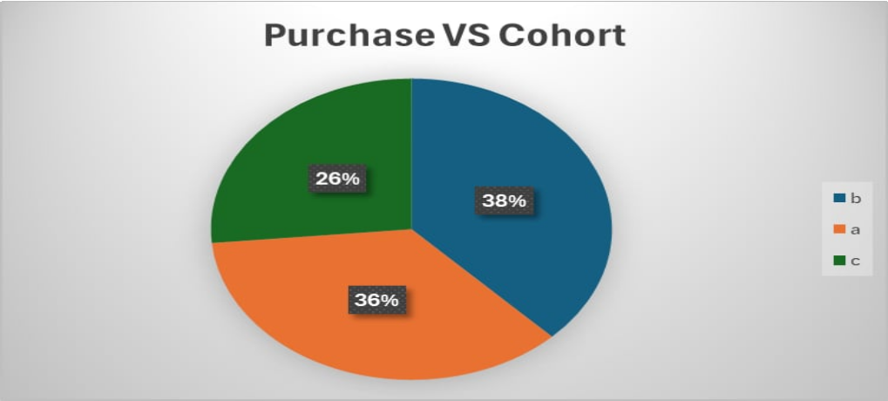

Answer to Question 2:

The data provided includes information about phone numbers, verified emails, and the presence of first and last names across three cohorts (a, b, and c). By comparing this information with the purchasing behavior of the cohorts, we can identify patterns and propose some theories.

Data summary:

Count of has_first_name | FALSE | TRUE | Grand Total
b | 85 | 156 | 241
a | 138 | 208 | 346
c | 142 | 219 | 361
Grand Total | 365 | 583 | 948
First Names:
Cohort "a" has 208 users with first names (60% of the cohort). Cohort "b" has 156 users with first names (65% of the cohort). Cohort "c" has 219 users with first names (61% of the cohort). Grand Total: 583 out of 948 users (61%) provided first names.

Count of has_last_name | FALSE | TRUE | Grand Total
c | 51 | 310 | 361
a | 59 | 287 | 346
b | 30 | 211 | 241
Grand Total | 140 | 808 | 948

Last Names:
Cohort "c" has the highest percentage of users with last names (310 out of 361, or 86%). Cohort "a" has 287 users with last names (83%).
Cohort "b" has 211 users with last names (88%).
Grand Total: 808 out of 948 users (85%) provided last names.

Count of has_verfied_email | FALSE | TRUE | Grand Total
b | 10 | 231 | 241
a | 180 | 166 | 346
c | 251 | 110 | 361
Grand Total | 441 | 507 | 948

Verified Emails:
Cohort "b" has the highest percentage of verified emails (231 out of 241, or 96%). Cohort "c" has the lowest percentage of verified emails (110 out of 361, or 30%). Cohort "a" is in the middle, with 166 verified emails out of 346 (48%).
Grand Total: 507 out of 948 users (53%) have verified emails.

Count of has_phone | FALSE | TRUE | Grand Total
a | 233 | 113 | 346
c | 275 | 86 | 361

b | 169 | 72 | 241
Grand Total | 677 | 271 | 948

Phone Numbers:
Cohort "b" has the highest percentage of users with phone numbers (72 out of 241, or 30%). Cohort "a" has 113 users with phone numbers (33%).
Cohort "c" has the lowest percentage of users with phone numbers (86 out of 361, or 24%). Grand Total: 271 out of 948 users (29%) have phone numbers.

Pattern & theory:
- Verified email users are more engaged and committed to the platform, which could drive higher purchase rates. Email verification might be an important step in the conversion funnel This supports the idea that email verification is strongly correlated with purchasing
behavior.

- Collecting phone numbers could indicate stronger user intent or engagement, as users who provide this information are likely more invested in the platform. Encouraging phone number collection might increase overall engagement and lead to more purchases Across
all cohorts, relatively few users provide phone numbers (29% overall).

Recommendation:
- Boost Email Verification: Target cohorts, especially "c," to increase verified emails, which could enhance engagement and sales.

- Encourage Profile Completion: Incentivize users to complete profiles (first name, last name, phone number) to foster a more personalized experience, particularly in cohort "c."
- Target Cohort "c": Implement targeted campaigns, such as incentives for profile completion and special offers for verified users, to improve engagement and purchasing.

